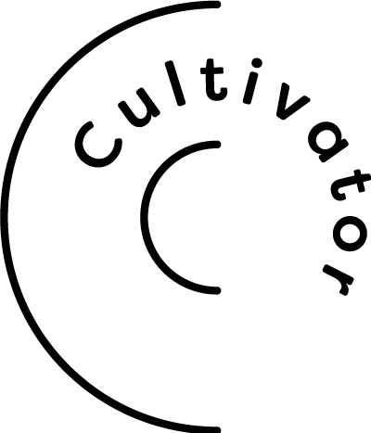
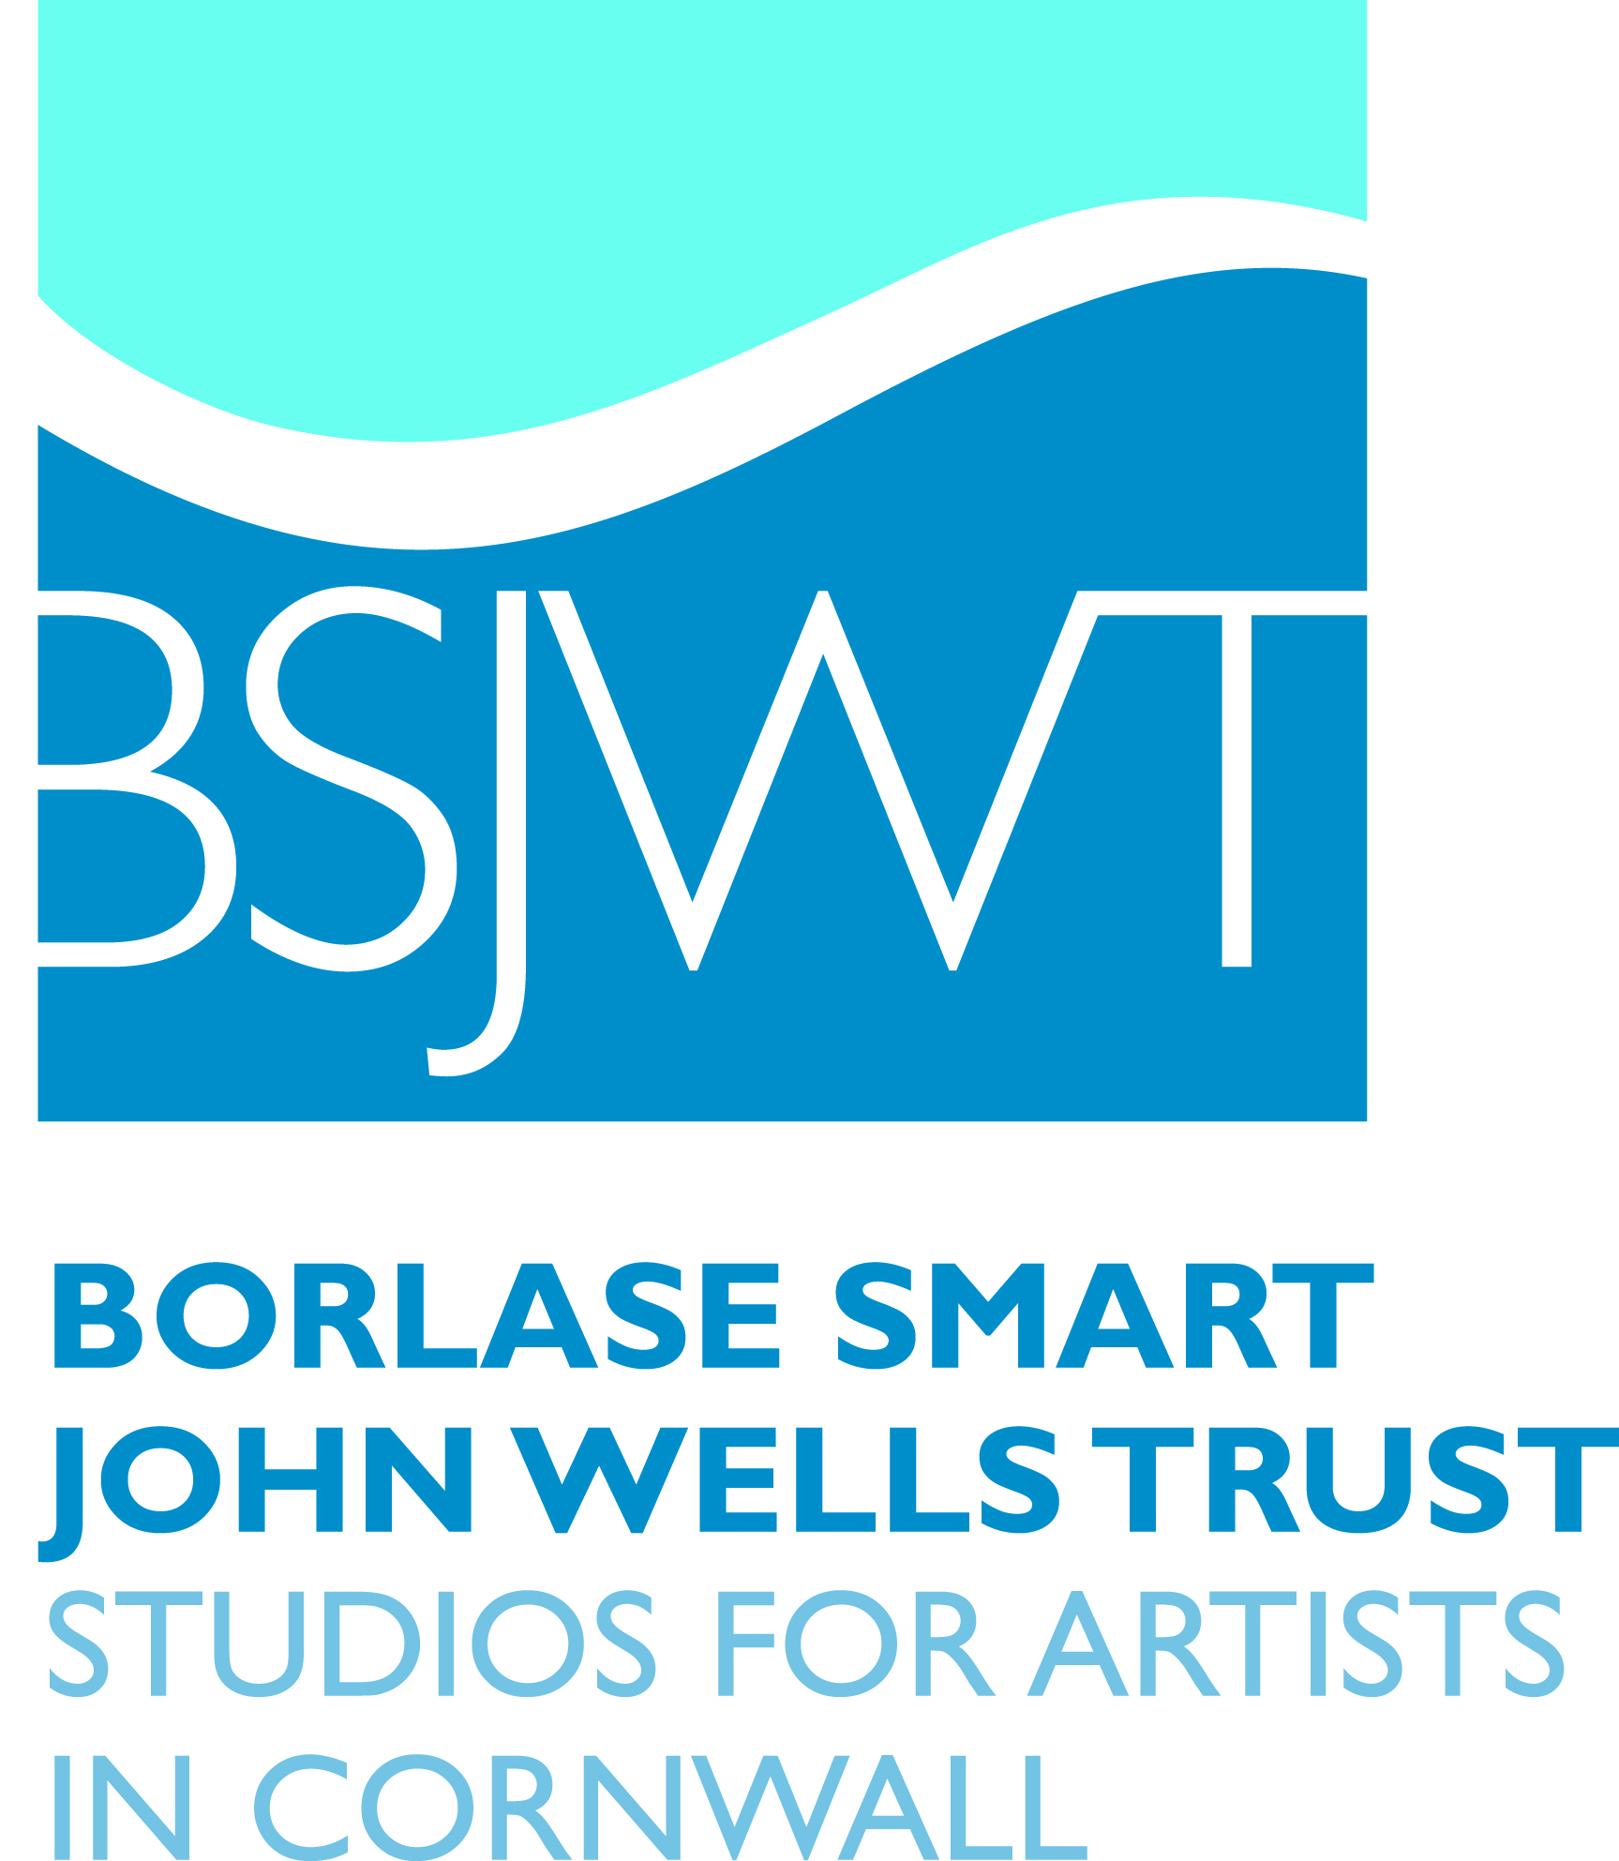

Porthmeor Studios Graduate Studio opportunity 2018-19 supported by Cultivator

Falmouth School of Art has been approached to be a partner in this opportunity for one of our graduates to apply for a year-long Graduate Studio Place at the prestigious Porthmeor Studios. We can nominate up to three artists to apply; to be eligible for nomination, you will need to have graduated from BA(Hons) Fine Art within the last five years.

This opportunity is funded and supported by the Cultivator Business and Skills Development Programme. Further eligibility requirements apply; see below.

To be considered for nomination by Falmouth School of Art, you will need to complete the short expression of interest, attached, and return it to schoolofart@falmouth.ac.uk by midday on Thursday 14 December.

The studio place- key information:
- On acceptance of the award, the selected applicant will work with a member of the Cultivator team to complete a funding application for the cost of the studio rental.
- Studio 11 will initially be available to the successful graduate (graduation date within the last 5 years) from 1st April 2018 to 31st March 2019 (this could be deferred to 1st June 2018 to 31st May 2019 if required).
- Applicants need to be a UK or EU resident or hold a valid work visa and will need to be resident in Cornwall (but can be planning to move to the area at the time of application) and will need to ensure that they are registered with HMRC before being formally offered the Cultivator Studio Award.
- The successful applicant will demonstrate their ambition and commitment to their studio practice, enthusiasm to engage in the Porthmeor Studios community and events and a commitment to developing a professional practice as a self-employed artist.
- The selected applicant will commit to one year in occupation of Studio 11 at Porthmeor Studios in St Ives, during which time Cultivator will undertake to pay the cost of the studio rental up to £1,800 for 12 months. The studio cost shortfall of approx. £30 per month will be paid for by the selected applicant.
- The selected applicant will also commit to working with the Cultivator Creative Graduate Business Advisor over the 12 month period, on a tailored coaching mentoring programme with access to other areas of support available on the Cultivator Programme.
- At the end of a year of support, the selected applicant will prepare an evaluative report for Porthmeor Studios and the Cultivator team describing their experience.

Timeline following your submission of an Expression of Interest:

- Friday 15 December – Falmouth School of Art will submit a shortlist of nominees to Borlase Smart John Wells Trust, and will notify all who have made an expression of interest whether they have been nominated
- Cultivator will then contact nominees and work with them toward and application
- Midday Monday 15 January – Deadline for submission of applications
- Interviews Thursday 8th February at Porthmeor Studios in St Ives, Cornwall

The Borlase Smart John Wells Trust is a charity offering high quality, affordable studio space for artists working in Cornwall. It owns and manages three historic artists’ studios: Grade II* listed Porthmeor Studios in St Ives, and Trewarveneth Studios and Grade II listed Anchor Studio in Newlyn, providing 22 studios for artists and 2 studios for the St Ives School of Painting.

Porthmeor and Anchor studios are probably the oldest working artists’ studios in the country, and are best known for the internationally significant artists who have been based there. Previous tenants have included Julius Olsson, Stanhope Forbes, Frances Hodgkins, Ben Nicholson, Patrick Heron, Francis Bacon, Terry Frost, Roger Hilton, Wilhelmina Barns- Graham, Peter Lanyon and John Wells. Porthmeor is also celebrated for its fishing connections. Originally built for the St Ives pilchard industry, Porthmeor Cellars are still used by fishermen, a unique reminder of the days when many of its neighbours were used by both artists and fishermen.

Cultivator is an innovative project providing an integrated programme of sector specific skills and business development support for Small to Medium Enterprises in Cornwall’s creative industries. It is funded by the European Social Fund, the European Regional Development Fund, Arts Council England and Cornwall Council.

Studio information on Porthmeor Studios: http://www.bsjwtrust.co.uk/location/porthmeor-studios/
More information on Studio 11 http://www.bsjwtrust.co.uk/studios/studio11/
More information on Cultivator https://cultivatorcornwall.org.uk/

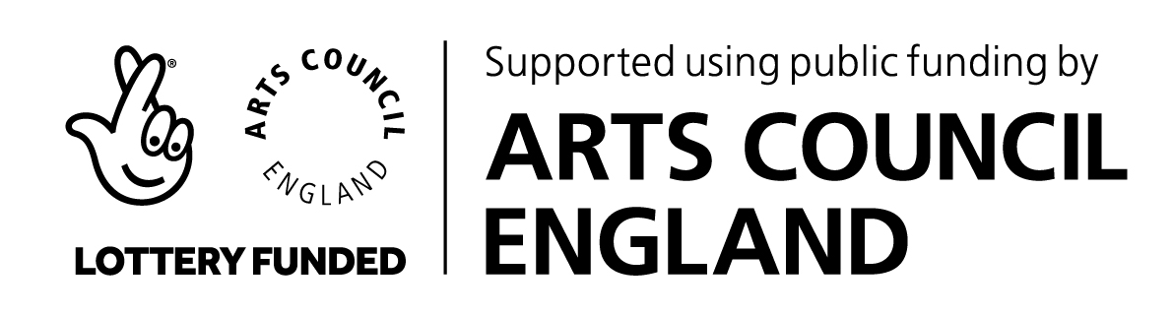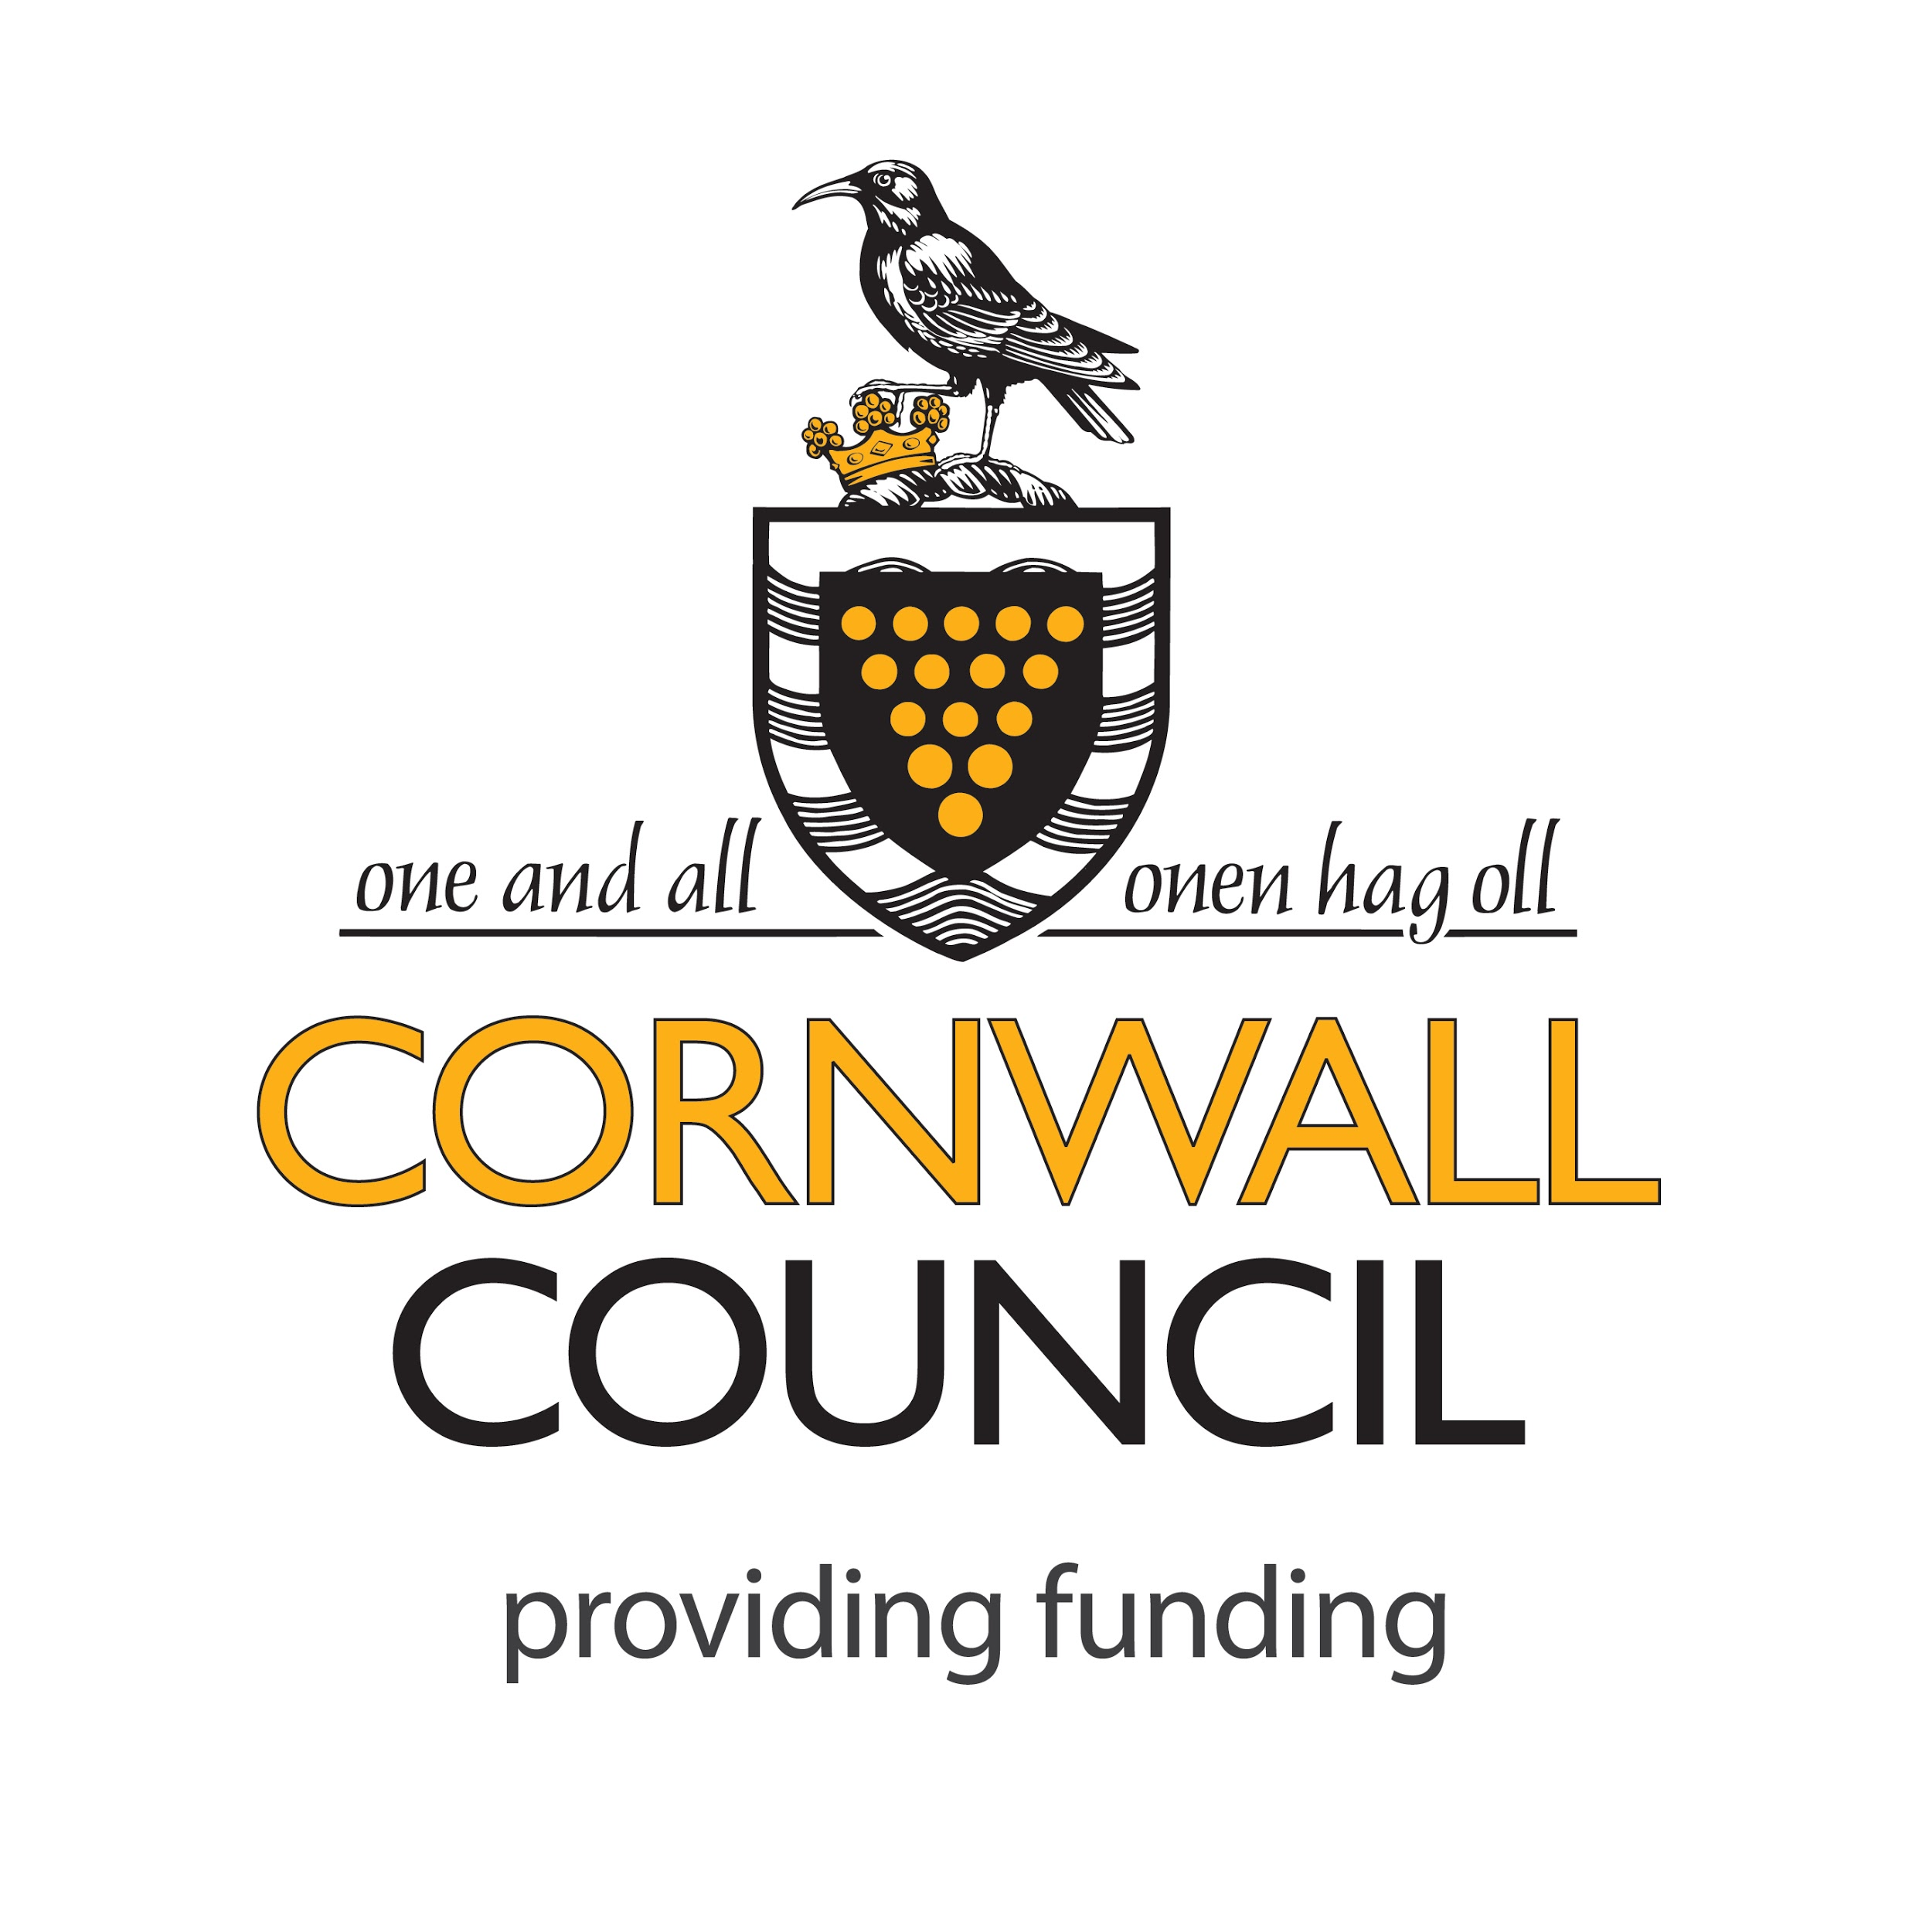

Cultivator is part of Creative Kernow, charity no. 292138, company no. 1727731 creativekernow.org.uk

CULTIVATOR PORTHMEOR STUDIOS GRADUATE PLACE 2018

EXPRESSION OF INTEREST

Submission deadline: Midday, Thursday 14 December
Outcomes: You will be notified on Friday 15 December whether or not you are being nominated by Falmouth School of Art to make an application for this Studio Place.

Your details
Name
Name on graduation (if different)
Year of completion of BA(Hons) Fine Art
Email address
Phone number/s
Website
If you do not currently have a professional website, please provide a link to online examples of your work, or submit a maximum of three images as a PDF and submit with this Expression of Interest.

How do you feel the Cultivator Graduate Studio Place at Porthmeor Studios will be of benefit to your practice and your development as a professional artist? (max 200 words)

What practical planning will you need to put in place in order to live in Cornwall and work in the studio in St. Ives over the course of a year? (max 200 words)

Please provide an artist’s statement of not more than 150 words.

I agree that if nominated I will work with cultivator toward submitting an application; and that if successful in that application, I will take up the residency as outlined on page 1 of this document

Signature …………………………………………………………………………..

