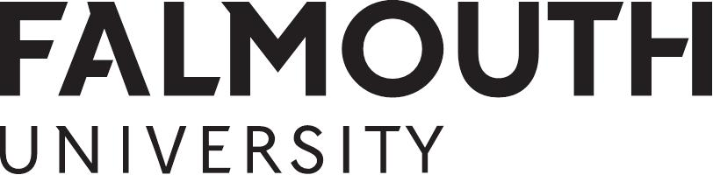

MA Creative Advertising - Creative Brief 2014

Product (What the advertising is selling.)
Innocent Smoothie (250 ml)

Objective (The job the advertising has to achieve.)
Remind the target audience of the benefits of Innocent pure fruit Smoothies.

Strategy (How the advertising will achieve its task.)
By convincing our target market that Innocent pure fruit Smoothies are a delicious, easy way to eat more healthily.

Target market (Who the advertising is aimed at.)
Young urban professionals.

Support (Why the product is of interest to the target market.)
- Made from pure fruit, not concentrate
- Nothing added, nothing taken away.
- 1 x 250 ml Smoothie = 2 of your recommended 5 units of fresh fruit/vegetables per day.
- Convenient single-serve packaging, easy to enjoy anywhere.

Proposition (The ‘hook’ that will attract the target market.)
Innocent pure fruit Smoothie. Healthy eating, made easy.

Competition (Who else is fighting for the attention of your target market in this area?)
Other fruit smoothies and fruit drinks. Fresh fruit.

Mandatory (What has to appear in the advertising)
Logo.

Tone of voice (The type of character the advertisement should have.)
Informative, honest and witty – see copy on pack.

Media requirement (where the advertising will appear)
- 1 bus shelter poster.
- 1 30 second radio script.
- An interactive execution in a digital medium

