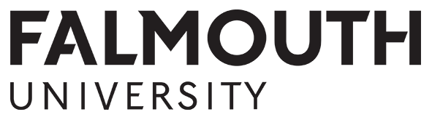
The Caroline Sassoon Emerging Artist Award 2018

Prize Summary

The Caroline Sassoon Emerging Artist Award is being launched to commemorate the occasion of 100 years since the birth of local artist, Caroline Sassoon.

The award is being offered by Caroline’s family who wish to continue her legacy by supporting artists’ development and enabling courage and exploration within an individual’s practise.

There is one award of £500 available to the winning applicant.

The award is open to all final year students enrolled on either Fine Art or Drawing within the Falmouth School of Art, and is intended to support the award recipient with their plans following completion of their course. It is hoped that the award will enable the recipient to fulfil an artistic ambition and undertake something that they would not otherwise be able to achieve.

Eligibility & Key Criteria
To be eligible to apply for the award:
- You must be enrolled for the 2018/19 academic year, on level 3 of either BA(Hons) Fine Art or BA(Hons) Drawing within the Falmouth School of Art.
Key criteria for the award are:
- Applicants need to demonstrate why being an artist is important to them, and where they hope their practice may take them, after their studies.
- The award is intended to help the recipient address any financial barriers to undertaking their plans and as such, need to provide details of their financial situation.
- The award recipient will be required to provide feedback on their experience, achievements and undertakings funded by the award.

How to Apply
Students wishing to apply should complete the Caroline Sassoon Emerging Artist Award 2018 application form. This can be found on the web page www.falmouth.ac.uk/student-funding/caroline-sassoon-award.
Completed applications should be submitted by email to: studentfunding@falmouth.ac.uk or by hand to: The Student Funding Office, the Hub, Falmouth Campus.

Please note:
ALL application forms must contain a personal signature - this can be a digital copy of your signature or a scanned copy of a hand-signed form sent as an attachment. Typed names are not sufficient and applications without a personal signature will not be accepted.

Any queries regarding the Caroline Sassoon Emerging Artist Award should be directed to the Student Funding Team at the email address above.

NO late applications will be considered.
Deadline for applications is:

midday on Friday 30th November 2018.

Judging

A Panel of Judges will consist of academic members of staff from the School of Art.

Applications will be assessed during December ’18 / January ‘19 and all applicants will receive an email (to their University email address), informing them of the outcome of their application, by Friday 1st February 2019.

